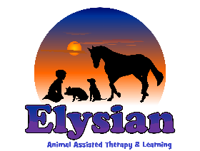
Referral form for Elysian 2023
Name of Child/Young Person |  |  |  |  |  | DOB and Age
Which Service are you referring for (Choose from list and specify in box below)
- Education Provision
- EOTAS Provision (Please specify number of days uer week)
- TWE Sessions (Please specify number of sessions per week)
- Therapy (50min weekly sessions )
- Therapeutic Animal Assisted Learning Sessions (50min sessions)
- ‘Other’
Service:

Which site are you referring to/preferred site? |  |  |  |  | Liss (Hamsphire) |  |  | Shamley Green (Guiildford, Surrey)
Name and Contact details of referrer
Please include title, address/work base, number and email
Name and Contact details of parents/carers.
Please include full names, address(es)/home and mobile number(s) and email(s)
GP Details
Please include Name, Practice details and number
About the Young Person:
Please outline reason for the referral. We would like to know about the background the positives, their likes and their challenges, along with what support they are currently accessing:
Please outline 3 Desired outcomes for this referral/intervention/individual |  |  | 1)  2)  3)
Please outline the current risks
Please outline any medical needs
Who is the current team around this child or young person, what other professionals are they working with (if any)?

Is there anything else we should know?
Please send to refer@elysianuk.org
You should hear from us within 14 days of receipt

