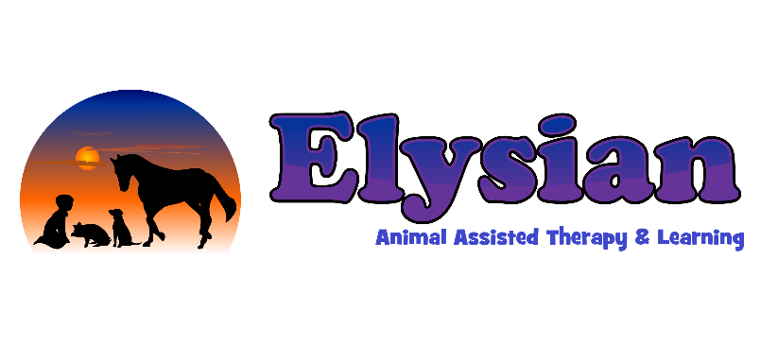

Consent for Activities involving Food at Elysian
From time to time we undertake activities involving preparing and /or tasting food. Therefore it is important that we know of any allergies or unsuitable foods for your Child/Young Person.
Please complete the form below and return to the staff via your child or to a member of staff on the gate.

Name of Child/Young Person_________________________________
Please tick the box to give consent for your child to take part in activities involving:
- Food Preparation
- Food Tasting
Please give details of any allergies, unsuitable foods or ingredients. If NONE, please state NONE.

I undertake to inform Elysian at once should any allergies or unsuitable foods be discovered during the year

Signature:____________________________________ Date:__________________
(of adult with legal responsibility for the child)

Name______________________________________________________________

Relationship to child:___________________________________________________

