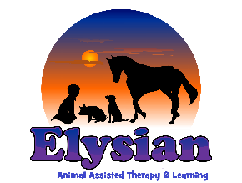
Information Sharing Consent Form

Name of Young Person:

I hereby give my permission for Elysian AAT CIC to share personal information with other service providers in connection with my care, including accessing and sharing my medical, and if applicable, mental health and police records. I agree to a referral being made to (add local supportive services), in order to support my needs. I understand that (the host organisations) may hold information gathered about me from the various agencies and as such my rights under the Data Protection Act will not be affected.

Statement of Consent:
- I understand that personal information is held about me.
- I have had the opportunity to discuss the implications of sharing or not sharing information about me.
- I agree that personal information about me may be shared and gathered from the following agencies:
  - NHS and other Health Services, including my GP practice
  - Early Intervention Service including the police
  - Adult Services
  - Mental Health Services
  - Education Support Services
  - Social Care
  - Voluntary Sector Organisations
  - Housing Providers

Are there any agencies you do not want us to share or gather additional information with? Please list them here:
______________________________________________________________________________________________________________________________________________

I agree to my information being shared and gathered between services

Your consent to share personal information is entirely voluntary and you may withdraw your consent at any time. Should you have any questions about this process, or wish to withdraw your consent please contact Charlotte Williams charlotte@elysianuk.org 01483898517

Name …………………………………………………………………..…………….

Address ………………………………………………………………....................

Post code …………………… Date of Birth …………………………..

Signature ……………………………………………………………….

Date ………………………

Signature of parent/Carer ……………………………………………………….

Print name ………………………………………………………………………….

