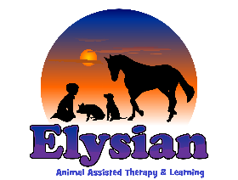
EDUCATION PLACEMENT REQUEST

Name of Child  /Young Person |  |  |  |  |  |  | DOB and Age
Which site are you referring to/preferred site? |  |  | Liss (Hampshire) |  |  | Shamley Green (Guildford, Surrey) |  |  | West Horsley (nr Leatherhead, Surrey)
In the main, our education placements are full time, although many learners will start with slow transitions due to anxiety and/or being out of school for an extended period. Please indicate here should you be requesting a part time /dual registration placement, and why:

Name. Role and Contact details of referrer
Please include title, address/work base, number and email
Name and Contact details of parents/carers.
Please include full names, address(es)/home and mobile number(s) and email(s)
GP Details
Please include name, practice and contact details
About the Child or Young Person:
Please outline reason for the referral. We would like to know about the background, the positives, their likes and their challenges, along with what support they are currently accessing. Please also include any reasons for why they are not currently in an education provision or the current status with services they are accessing. We need recent and relevant information that may not be on the EHCP to help us assess the referral
Please outline 3 desired current priority outcomes for this learner.  These are really important to us, as they set the scene for the referral and how we can meet their needs. |  |  |  | 1)  2)  3)
Please outline the current risks or triggers
(For example, mental health triggers, physical aggression towards others when unable to communicate, climbing up trees, buildings and fences)
Please outline any medical needs
Who is the current team around this child or young person, what other professionals are they working with (if any)?
Include name, role and contact details

Is there anything else we should know?

Please send to refer@elysianuk.org

We aim to reply to your referral within 10 working days, however we do receive a high volume of referrals, and if you have not heard back from us within this time, please do contact us to enquire further.

Please also attach EHCP, latest review and any relevant assessments

