Therapeutic Process Document

This is an ongoing document and subject to regular reviews as the therapeutic provision expands and develops.

Introduction
The purpose of this document is to ensure that each young person’s needs are assessed, monitored, and reviewed to support them in feeling safe and developing positive relationships, a theme that underpins everything we do at Elysian. This will improve their emotional wellbeing and sense of self and help them find better ways to engage and thrive in all areas of their life and develop a positive learning culture.
Aims
To ensure that all young people can access a variety of therapeutic interventions that are individually tailored to their needs and are evidenced based.
To ensure that there is scrutiny with regards to the therapy offered and that practitioners are actively supporting improvement.
Theoretical Evidence Base
The therapy team will ensure evidence based theoretical approaches underpin the work they do with young people and inform key messages to staff to ensure there is a consistent approach when working with young people.
Attachment Theory (Ainsworth and Bowlby) the theory behind how we interact with others and build relationships. Children who have experienced trauma, abuse and neglect in their early lives are often said to have attachment difficulties which affects their ability to form positive relationships.
Trauma Theory (Dr Bruce Perry) When trying to understand the complex worlds of young people who have suffered abuse and neglect it is most useful to integrate the theories of trauma, attachment and child development.
Erik Erikson’s Eight Stages of Psycho-Social Development states that personality develops through eight stages of psychosocial development. Successful completion of each stage results in a healthy personality and the acquisition of basic virtues. Basic virtues are characteristic strengths which can then be used to resolve subsequent crises. Failure to successfully complete a stage can result in a reduced ability to complete further stages and therefore a person may struggle in certain areas of their life and sense of self. These stages, however, can be resolved successfully at later stages with the right input.
Maslow’s Hierarchy of Need states that a person needs to have their basic needs met first for example, food, warmth, safety, sense of belonging before they can progress to meeting more specific developmental goals.
Rogers Theory of Self Actualisation. Rogers believed that a growth producing climate is characterised by three conditions – the realness or congruence of the therapist in relationship with the client, the ability of the therapist to offer the client total acceptance or unconditional positive regard and empathic understanding. The relationship between client and therapist is all important and the belief is that we all have the capacity to grow towards the fulfilment of our unique identities – self actualisation. This model fits well with our vision at Elysian where the young people we work with have distorted and negative views of self and demonstrate accompanying behaviours which serve as a defence.
Our relationships with young people are all important and it is within these relationships that the growth process can be encouraged. It has been described as the therapist or therapeutic environment providing a different soil and climate in which the individual can flourish as the unique individual he or she is.
Therapeutic Approaches and Delivery

At Elysian we continue to strive towards a trauma informed ‘whole-school approach’ to mental health and emotional wellbeing as the evidence tells us that there is a clear link between mental health and achievement. This is also in line with the Government’s green paper ‘Transforming children and young people’s mental health provision’.
The whole-school approach is about developing a culture and ethos where everyone feels they belong and creating a feeling of respect and inclusivity.

The PACE model underpins the way we work with young people. PACE is an approach developed by Dr Dan Hughes, Pace stands for Playfulness, Acceptance, Curiosity and Empathy. Using these basic principles in everyday interaction with our young people will help to promote the experience of safety. Young people need to feel a sense of connection and safety before they can engage the thoughtful, articulate and problem-solving areas of their brain to be in a place where they feel ready to learn.
Research indicates that young people who have experienced Adverse Childhood Experiences (ACES) have a greater likelihood of experiencing mental health problems and are less likely to thrive in all areas of life so having an understanding of each young person’s ACES is vital to the way we work with them.
Zones of Regulation (ZOR)
The ZOR is a framework and simple programme for teaching young people strategies or tools to develop their awareness of their emotional and sensory needs. The ZOR uses colours to help young people show how they are feeling in the moment. They can then develop a self-awareness with regards to their emotions with self-identified strategies to support self-regulation. By understanding how to notice that body signals and being aware of triggers young people can learn to regulate better and help those around them to understand what support they need.
At Elysian we have found that young people do not always feel comfortable working with colours and want to take ownership of their own strategies. They have been involved in designing characters that signify the different zones and these have been laminated on to keyrings which are user friendly for the farm environment. This is another example of how Elysian can work with young people in an individualised way.

Animal Assisted Learning and Therapy

Interactions with animals can reduce stress levels and provide comfort. Animals tend to respond to our behaviour, to sense our innermost thoughts and feelings, especially the ones we cannot necessarily express in words.
Horses, dogs, cats, goats (to name but a few) aid us in increasing awareness of our own behaviour. How an animal responds to a person’s actions, like backing away if a person approaches to quickly or aggressively, can point out how that person’s behaviour may be affecting the other people s/he interacts with.
At times, the most therapeutic activity can be to simply ‘be’ with the animals. Particularly the larger and more powerful animals such as horses or cows, create natural opportunities for someone to overcome fear and develop confidence. Mindfulness exercises can be built into these sessions. Observing the animals can be beneficial, providing opportunities for young people to project their beliefs and as such share about themselves in an emotionally safe way. Simple questions such as ‘which horse is most like you and why?’ can prompt insightful conversations.
Skills based activities can also be facilitated – exercises which incorporate animal care such as grooming, feeding, cleaning… provide opportunities to develop patience, respect, awareness, observation and communication.
Every session with an animal/s is a potential metaphor (parallels the animals, equipment… can be used as a symbol for something else). Effective use of metaphor can be a powerful catalyst for affecting change. For example, a young person may say that a certain individual is not respecting their space. In this context the animal (horses are particularly effective) could become a physical metaphor of the challenge and the person can try out different ways of relating and communicating.
Alongside the therapeutic work with the animals, we may use an integrative approach bringing in other approaches that allow us to find the right approach that is specific to each young person.

Occupational Therapy
Occupational therapy is described by the World Federation of Occupational Therapists as ‘a client-centred health profession concerned with promoting health and well being through occupation’ (2012). It ‘provides practical support to empower people to facilitate recovery and overcome barriers preventing them from doing the activities (or occupations) that matter to them’ (Royal College of Occupational Therapists 2021). The therapy is goal-orientated, and occupation is both a means and an end to treatment. Activities may be used therapeutically to achieve a goal, e.g. an animal-feeding task used to develop organisational skills. Or a young people may be supported towards the goal of a specific occupation, e.g. learning sensory strategies to help them stay regulated to eat their lunch with their friends. Occupational therapy at Elysian makes full use of the rich occupational opportunities available in a farm environment, incorporating animals, daily farm activities and the range of indoor and outdoor environments.
Occupational therapy at Elysian primarily draws on Kielhofner’s Model of Human Occupation, or MOHO (Taylor 2017), to consider how a young person’s motivation, roles and routines, social communication and interaction skills, processing skills, motor skills and the environment all impact on their ability to successfully participate in activities that they want or need to do. MOHO assessments and other standardised assessments, such as the Adolescent/Adult Sensory Profile, inform the occupational therapy process. Elysian’s occupational therapy provision can help with a range of needs, including, but not limited to: motivation including building self esteem; developing identity through exploring values, interests and roles; managing routines and transitions; independent living skills; sensory processing needs; social skills; organisational skills; decision-making and problem-solving; attention difficulties; fine and gross motor skills. Occupational therapy takes a holistic approach and will also consider a young person’s functioning outside of Elysian and the impact of this on their time here, and vice versa, with the aim of enhancing overall wellbeing.
Ecotherapy
Research has shown that nature can improve your emotional health. At Elysian we are incredibly lucky to have 104 acres at our disposal with a mixture of wooded areas, streams and fields where young people can immerse themselves in nature using techniques such as breathing, grounding and mindfulness to provide a level of reflectiveness and calm.
Walk and Talk Therapy
Some young people may find the thought of face-to-face counselling indoors, in a confined space, uncomfortable. So, Walk and Talk Sessions may be a helpful alternative in the beautiful Elysian countryside. Nature has the capacity to calm, heal, energise, and inspire us. Walk and Talk sessions are based on this belief. The physical health benefits are well known but recent international research also suggests that it can improve our psychological health and mental wellbeing by enhancing our mood and levels of self-esteem.
Walking with an experienced therapist, who can listen and help you make sense of your emotional problems, can help to create a new and less intense experience of therapy.
Cognitive Behavioural Therapy (CBT)
CBT was initially developed in America during the 1950’s by Professor Aaron Beck and was developed as a self-help form of psychotherapy to empower individuals to make practical changes in their thoughts and actions to improve how they feel. It does not focus on past traumas but on present difficulties providing a helpful set of tools to help you make sense of problems you may be facing in everyday life by breaking them down into smaller more manageable pieces. It breaks problems down into thoughts, feelings, physical reactions and behaviours.
CBT has proven to be one of the most effective ways of improving our wellbeing as a self-help approach and has been endorsed by the National Institute of Clinical Excellence (NICE: www.nice.org.uk) as a recommended treatment option.
How is therapy delivered
Therapy will be delivered depending on the needs of the young person and a Universal, Targeted and Specialist Model is used to underpin delivery (please refer to attached appendices). All young peoples’ needs are evolving so they can move up and down depending on need. Targets will be reviewed to reflect progress and changing needs applying a strengths-based approach.

Assessment and Review Process
Upon entry each young person will be reviewed by the Therapy team to ascertain presenting needs and an agreement with regards to therapeutic plan will be drawn up and implemented by the lead therapist. This may include observations by the Occupational Therapist to complete an assessment or a meeting with the Integrative Therapist to agree a therapeutic plan and goals. The therapeutic needs of each young person will be reviewed and monitored termly via a Therapeutic Tracker.
Reporting and Performance Management
Assessment completed by Lead Therapist
Goals and entry/exit questionnaire to be completed by Lead Therapist with review date set.
Therapy notes are recorded on the young person’s file and stored digitally. Separate folders for modality for example OT or Integrative Therapy
Sessions will be reviewed in monthly line management supervision between therapist and Head of Therapy and discussed in weekly therapy meeting to ensure management oversight and a multi-professional approach.
Elysian will fund external monthly reflective supervision for the therapists if needed.
A brief therapy report will be provided at the end of each term and an evaluation of the effectiveness of the therapy.
Data from outcome measures will be collected and shared with the Senior Leadership Team and Advisory Board to inform efficacy and evaluation of service.

Date of Review: 06/01/2022 by Julie Wilby

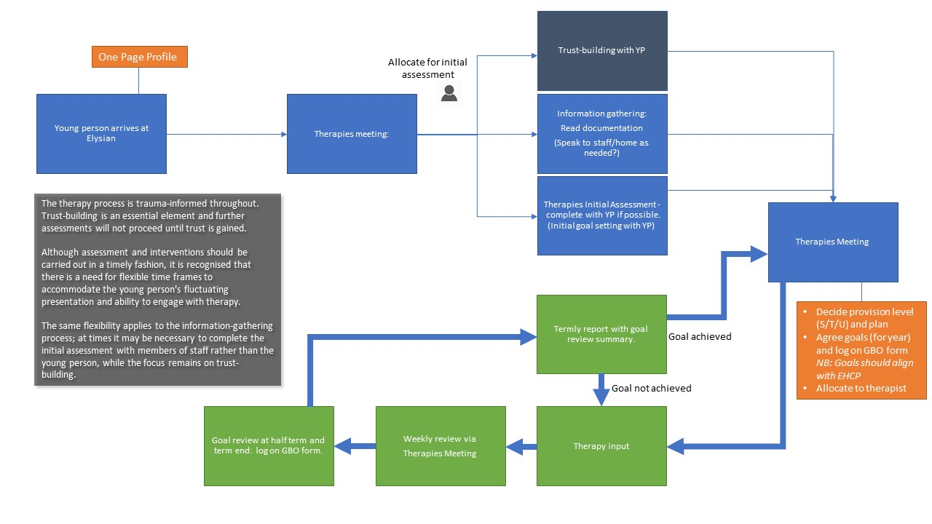
Appendix 1 – Provision Delivery Flowchart

Appendix 2 Delivery Model, Specialist, Targeted and Unviersal
